CLASS DIAGRAM FOR RAW MATERIAL STOCK

RawMaterialStock
-stockId: String
-orderId: String
-price_per_unit: double
-quantity_Value: double
-quantity_unit: double
-price : double
-warehouseId: String
-deliveryDate: Date
-manufacturingDate: Date
-expiryDate: Date
-qualityCheck: String
-processDate: Date

-processDate: Date

<<RawMaterialServiceImpl>>
Java Class
+addStock(RawMaterialStock): RawMaterialStock
+trackRawMaterialOrder(String orderId): RawMaterialStock
+updateRawMaterialStock(RawMaterialStock, Date date) :String
+fetchAllStocks(): List<RawMaterialStock>
+validateManufacturingDate(Date date): boolean
+validateExpiryDate(Date date): boolean
Supplier
-supplierId : int
-supplierName: String
-supplierAddress: String
-supplierPhoneNo: int
<<Controller>> IRawMaterialService service, ISupplierService supplierService
+addStock(@RequestBody DTO): RawMaterialStock
+fetchStock(@PathVariable(id): RawMaterialStock
+fetchAllRawMaterialStocks(): List<RawMaterialStock>

+addSupplier(@RequestBody SuppierDto) : Supplier
+fetchSupplier(@PathVariable(id): Supplier
+fetchAllSuppliers(): List<Supplier>

<<RawMaterialService>> Interface

<<RawMaterialDao>>
Interface

<<SupplierServiceImpl>> Java Class
+addSupplier(Supplier): Supplier
+fetchSupplierById(int id): Supplier
+fetchAllSuppliers(): List<Supplier>
<<SupplierDao>>
Interface

<<SupplierService>>Interface

SEQUENCE DIAGRAM FOR RAW MATERIAL STOCK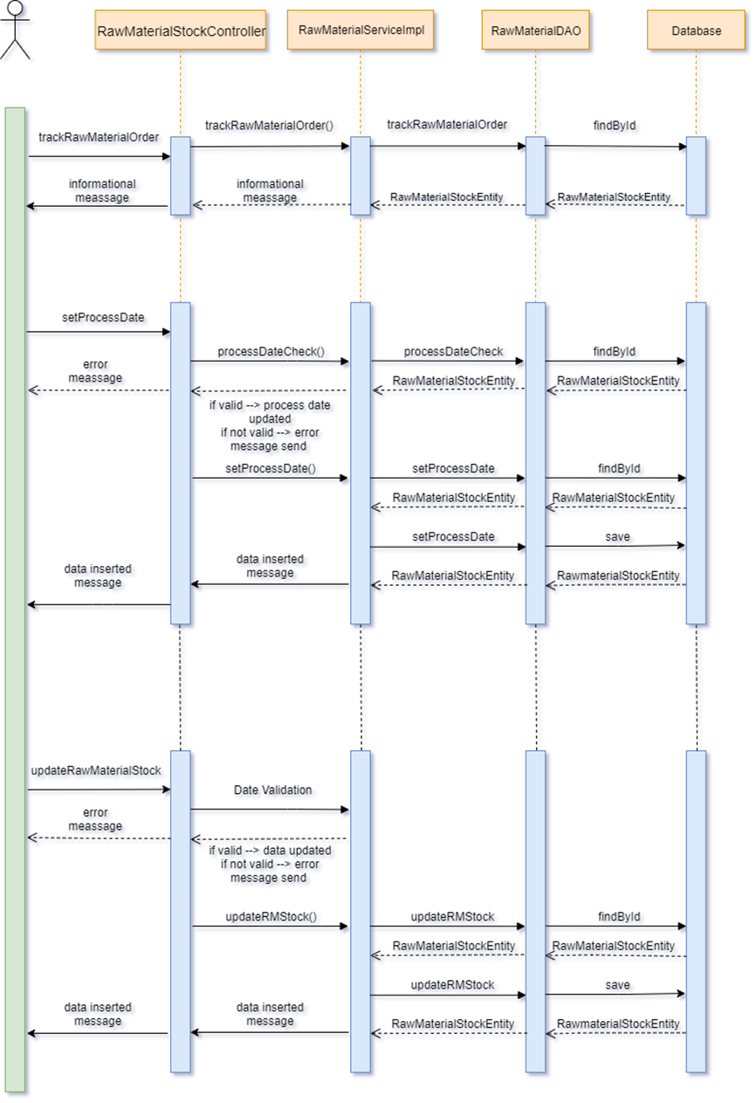
USE CASE DIAGRAM FOR RAW MATERIAL STOCK/ORDER
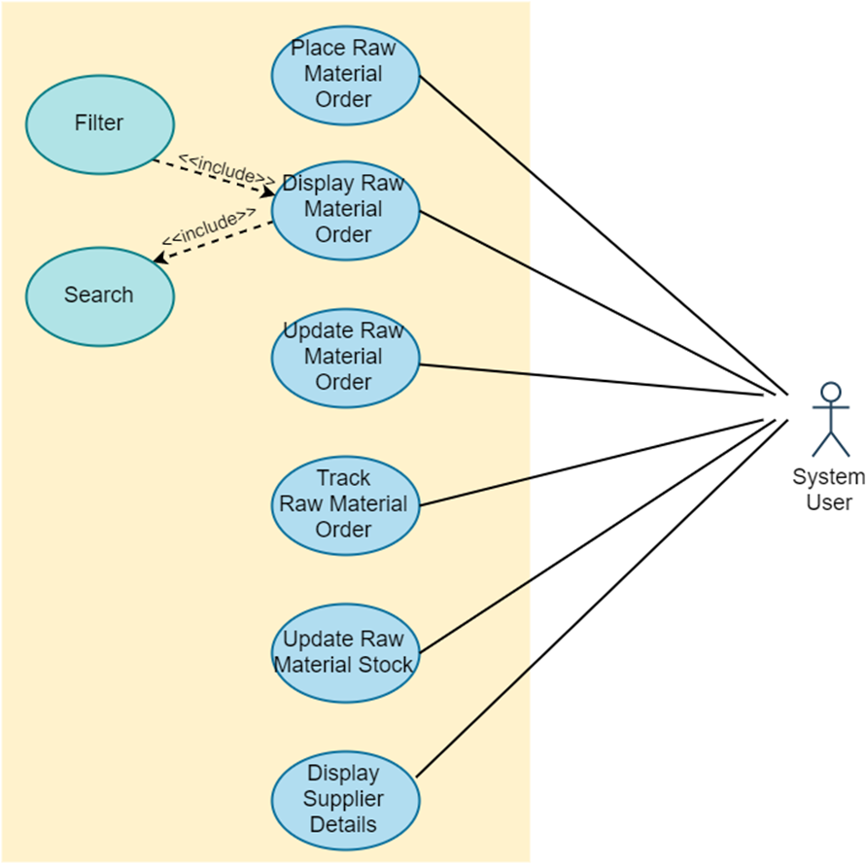

ER DIAGRAM FOR RAW MATERIAL STOCK
Supplier
-supplierId : int (PK)
-supplierName: String
-supplierAddress: String
-supplierPhoneNo: int

RawMaterialStock
-stockId: String (PK)
-orderId: String
-price_per_unit: double
-quantity_Value: double
-quantity_unit: double
-price : double
-warehouseId: String
-deliveryDate: Date
-manufacturingDate: Date
-expiryDate: Date
-qualityCheck: String
-processDate: Date

